Intermediate Algebra Lecture 8.1: Graphing Lines. Equations of Parallel and Perpendicular Lines

Linear functions

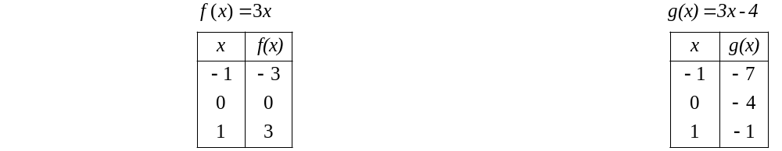

The 3 co-efficient of x of both functions represent the slope of the lines

f(x)=3x can be rewritten as f(x) =3x + 0 where
+0 equal the y intercept

g(x)=3x-4, where -4 represents the y intercept

If the slope of the lines are equal then the lines a parallel.

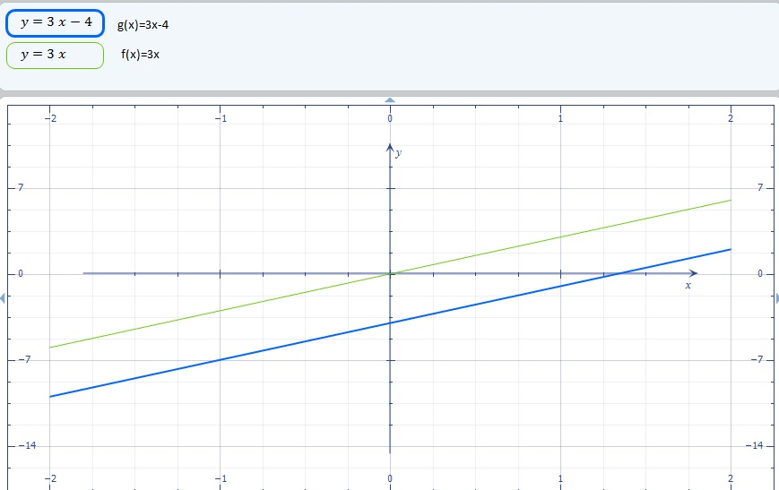

Vertical line test

A function must past the vertical line test. In other words a vertical line can only pass the graph of the function in only one spot
A function can only have one output, y, for each unique input, x.

Types of linear functions
- 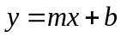 slope intercept form, slope is m slope is 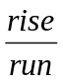 b = y intercept
Example
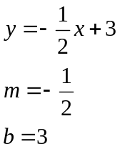
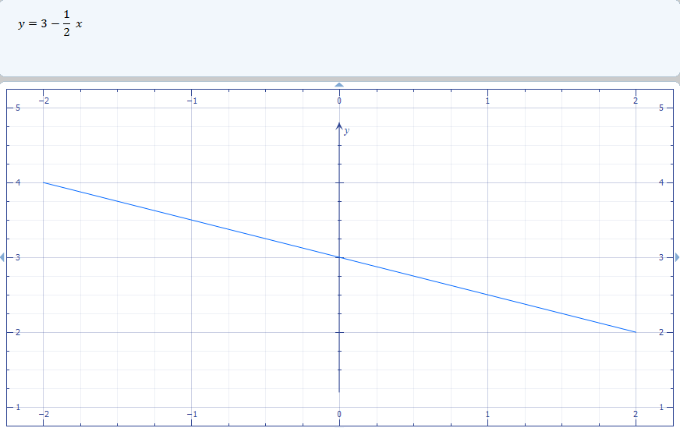

- 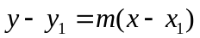 point slope form, where variables with a subscript indicate a actual point
Where m is the slope where 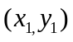 = a point on the line

- y=c, where c is a constant. m or slope is zero, horizontal line, constant is the y intercept (0,c)

Example
Write the equation of a line with a slope of -2 and a y-intercept of (0, 3/4)
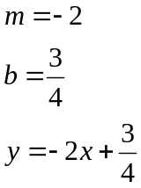

Find the slope between any two points

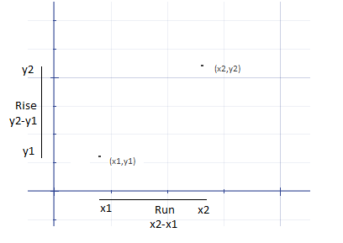

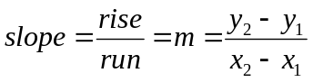

Example
Find the slope between any two points and write the line equation

(3,0) and (-2,4)
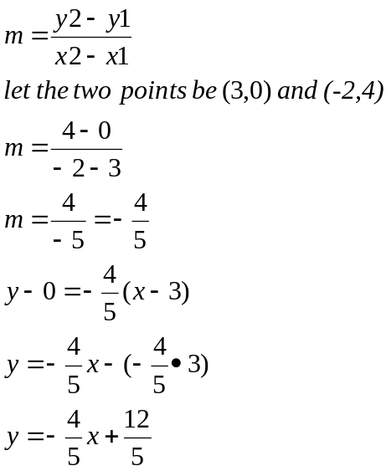

Example
Find the slope between any two points and write the line equation

(-1,2) and (2,0)

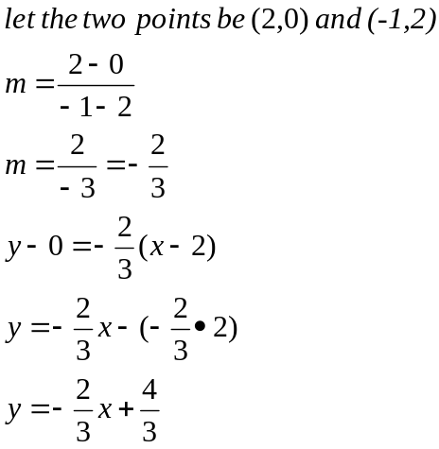

Example
Write the equation of the horizontal lines containing the points
(-1,6) y=6

(6-2) y=-2

Example
Write the equation of a line containing the point (-1,2) and
parallel to 3x+y=5

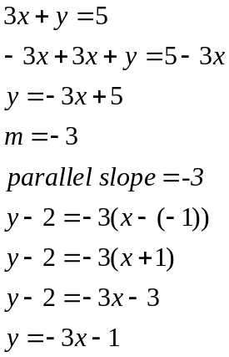

Perpendicular lines
When lines meet with a 90 degree angle
The lines must have a negative reciprocal slopes

Example
Write the equation of a line containing the point (8,-3) and
parallel to 3x+4y=1

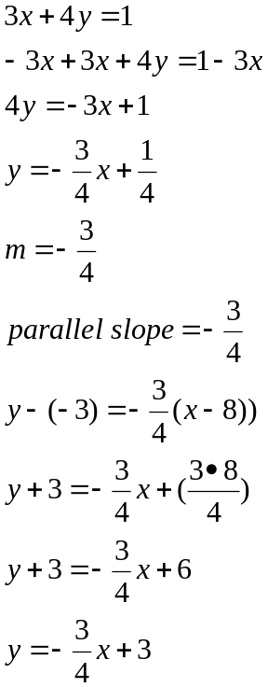

Example
Write the equation of a line containing the point (3,4) and
Perpendicular to line 2x+4y=5
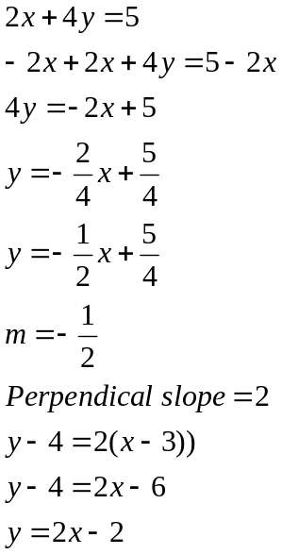

Example
Write the equation of a line containing the point (8,-3) and
Perpendicular to 3x+4y=1

